**Not Cease from Mental Fight: William Blake and the Question of Agency**

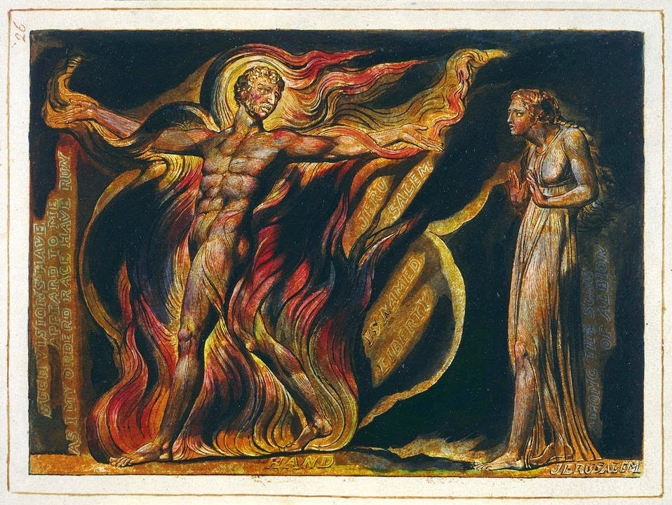

William Blake’s Jerusalem

Youth of delight! come hither

And see the opening morn,

Image of Truth new-born.[1]

Creative and unorthodox, William Blake has often been associated with the radical potential of Christianity. Drawing on the prophets of the Old Testament, Blake’s writings are full of bold and dramatic symbolism, targeting both priest and king, and describing an alternative vision of reality in accordance with what he saw as the spiritual demand for justice and liberty.

Although in death he has been widely applauded as a genius – whether by artists like Patti Smith or Paul Nash, or political thinkers like E. P. Thompson -- he was largely neglected in his own lifetime. To paraphrase a different figure from a different age, Blake was too radical for the spiritualists and too spiritual for the radicals, leaving him isolated from many of his peers. For all his spiritual fervour, he is only known to have ever attended one gathering or congregation of believers, the New Church of the Swedenborgians, which he had abandoned by the 1790s on account of ‘priestcraft’ creeping into the originally antinomian spirit of the movement. Similarly, though he did move in radical political circles, counting Mary Wollstonecraft, Thomas Paine, Joseph Priestly, and William Godwin among his fellows, he clashed with them repeatedly over their assorted materialist and rationalist philosophies. “Himself [Blake] a heretic among the orthodox, here among the infidels he was a saint and staunchly defended Christianity – the spirit of it – against these strangely assorted disputants.” We have record of at least one argument between Blake and Paine; “In one of their conversations, Paine said that religion was a law & a tye to all able minds. Blake on the other hand said what he was always asserting, that the religion of Jesus, was a perfect law of Liberty.”[2]

To Blake’s mind, materialism and rationalism are not ways of escaping the oppression of ‘priestcraft’ (that is, organised religion) but direct corollaries of it. Priestcraft’s error is not that it depends on realities that do not exist, but that it prevents the human spirit from ever attaining to such realities. It is not otherworldly, but on the contrary, it binds us to this world. Similarly, materialism absorbs us into the mechanistic predeterminations of the physical universe, and rationalism measures all reality by pre-established laws, fixed in the mind, inadequate to the apprehension of higher things. What was needed was a recognition that not all things could be accounted for by rational laws or material causality – a recognition of the possibility of breaking free of the present order of things.

These ideas were almost certainly related to Blake’s own experience. As a child he saw angels on the hills outside London, and later he recounts discussing his art with his dead brother and the Virgin Mary. But this esotericism also represents a serious engagement with the philosophical and political conflicts of the day. ‘Science’ as we now understand the term had not yet become the dominant epistemological paradigm, and rationalism, materialism, and Newtonian physics were furiously debated in the salons and public houses of London. But the conflicts of his age were not merely philosophical – Blake lived through both the American and French Revolutions and the upheavals that followed. In the summer of 1792, as Louis XVI was deposed, it seemed to some that revolution might be just around the corner in England too. Blake’s worldview wasn’t merely formed through abstract speculation, but by his passionate engagement with the issues of the day, his embrace of revolutionary currents in the name of ‘the perfect law of Liberty’.

For example, while his fellows followed the events of American Revolution in the newspapers, Blake watched a cosmic battle between the divine figures of Orc and the Angel of Albion. His poem *America: A Prophecy* was the first time Orc had appeared in Blake’s writing, but the figure emerged from imaginings that had preoccupied him for quite some time, and on which he would continue to elaborate throughout his life. “For the moment, however,” Peter Ackroyd writes, “their roles remain simple – Orc, the principle of energy and rebellion, stands against Urizen, who is tyrant, priest, and lawgiver.”[3] These figures provided Blake with a dramatic cast through which to comment on the events of the war. America is represented in Orc, who rises from the Atlantic to defy the Angel of Albion and drives the Angel of Boston to revolt. Human figures populate the poem too – Washington, Franklin, Paine, and the King of England among others – but they are not the primary actors in the narrative. Rather, their actions are always seen in relation to wider forces; the rebellion of Orc and his angels, and Urizen’s desire for order. In Blake’s eyes, history is not determined merely by the actions of ‘great men’, nor is it ‘just one damn thing after another’; rather, it is battle between forces that offer a glimpse into the Eternal World.

Fury, rage, madness, in a wind swept through America;

And the red flames of Orc, that folded roaring, fierce, around

The angry shores; and the fierce rushing of th’ inhabitants together![4]

The hinge around which such a vision revolves is agency, or as Blake put it, liberty. In his view, if all things can be reduced to either an abstract rationality or to material causality, then the natural result will be a grim determinism, sanctifying the world of priests and kings that was so abhorrent to his sense of justice. As far as Blake was concerned, to accept such a view of the world is to accept the present state of affairs as natural – in all of its cruelty and suffering - and to cut oneself off from any possibility of another world. This other world was what Blake claimed to perceive in his visions and to describe in his poetry. Whereas the materialist and rationalist philosophies of his day made one the victim of determinism, by setting his sights beyond the surface of history, Blake sought to present the possibility of action beyond the present state of affairs.

However, the strident denunciation of materialism does create a certain contradiction in Blake’s thought. On the one hand, for him this meant the rejection of the conditions that prevailed in the material world. He refused to allow the rank deprivation and injustice he perceived all around him to exhaust his understanding of the world, and instead strived to envision a greater reality, where such evils would be no more. On the other hand, by characterising political events as battles between cosmic forces transcending the material world, Blake risks the same fatalism that he condemned in his contemporaries. The history of all hitherto existing societies becomes the history of a struggle between vast cosmic principles, beyond anything that might be achieved by political actors in this world. Whilst for Blake, the transcendence of material things was a manifestation of liberty, it is difficult to see where human agency in history, the ability to change the situation one finds oneself in, fits in his spiritual vision.

We have already described Blake as at once too spiritual for the radicals and too radical for the spiritualists. In some ways then, it is perhaps appropriate that these flaws in Blake’s thought parallel with those targeted by both early Christian polemics against the heretical groups known as ‘gnostics’ and Marx’s critique of German Idealism.

By the second century, many groups were denying that the material world was a primary reality of human life, treating it rather as an error at best, and at worst, a diabolic scheme to keep the soul from discovering its true nature. According to such so-called ‘gnostics’, Christ did not come to save the world, but to save us *from* the world. By attaining spiritual knowledge (‘γνωσις’ or ‘gnosis’), they claimed that one could transcend the fixed laws of the material world, in what they saw as the true liberty of the Spirit.

However, for those groups who later became the established ‘orthodox’ Christian church, such a theology was not merely an insult to the dignity of the world and blasphemy against the God who created it, but also a dangerous forfeiting of ethical responsibility. It is not uncommon in orthodox texts to find condemnations of the gnostics, whom they accused of engaging in riotous orgies with little regard for family ties or other social norms. After all, if the body is to be discarded in the pursuit of salvation, what do one’s actions in the body matter? These claims are doubtless at least partially exaggerated, yet it is not difficult to see parallels between this and Blake’s own libertine sexual ethics, often interpreted as a ‘celebration of the flesh’, though it appears that for Blake this referred more to theoretical principles than any actual sexual exploits. Regardless of whether either the Gnostics or Blake lived up to their reputations, one cannot help but ask what place there is for practices of ethical formation, the formation of agency, of how one relates to the world and others in it, in a schema that rejects that world entirely. How does rejecting the material world – including, in Blake’s case, the priestcraft and sacrament of traditional Christianity - not merely trivialise the injustice one finds in it, rather than ‘liberate’ one from it as Blake claimed?

If the problem with gnosticism – and, to a degree, with Blake - is an over-idealism, at the expense of the material world, one might draw a parallel between this critique and the writings of the young Karl Marx, as he began to make his name in the 1840s. At this time, a philosophical circle known as the ‘Young Hegelians’ had denounced older currents in German philosophy as merely ideological window dressing for social conservatism, and offered new interpretations of the world in response. Ludwig Feuerbach, for example, saw religion as the transcendentalising of human attributes into an ideal image, ‘God’. However, as Marx pointed out, the commentator on religion cannot merely treat it as reflecting some abstract universal idea of ‘human nature’ (how could it, given the great diversity of religion around the world?), but rather as the product of the material conditions in which it arises. As such, Feuerbach’s uncritical materialism is merely the affirmation of the present state of affairs, just like the idealism he claims to reject. For Marx, this will always be the result of an exclusive preoccupation with ideas to the exclusion of the material world, hence his famous dictum; “The philosophers have only interpreted the world, in various ways; the point is to change it.” The visions of William Blake are highly creative and provocative interpretations of the world, purporting to offer true liberty from oppression – but it is unclear exactly how these might be put into practice as political projects that actually create the liberty he sought. Ultimately, Blake cannot fully account for the practices of agency that make both ethical formation and political struggle possible.

Politics can often be a discouraging thing. It would be easy to see our present crisis - the ongoing decay of the capitalist order and the resurgence of the global far-right – as an inevitability, and while this isn’t quite incorrect, it would be a mistake to lapse into such facile cynicism. It is important that we are reminded that another world *is* possible, that the present is not absolute. William Blake was a visionary, in a very literal sense, and his stubborn refusal to separate his Christianity from his revolutionary politics makes his work valuable and important for those of us invested in the relationship between faith and political struggles. However, his knee-jerk anti-materialism can reproduce the same suspension of agency he decried in his opponents, something that should make us pause before adopting visionary or esoteric radicalisms such as have proliferated in radical Christian circles since the Reformation. Whilst it is easy to romanticise ‘heretical’ strains of Christianity, how are we to change the world, if we seek only to escape it?

*Jonathan Murden is an Orthodox Christian and theology undergraduate, currently based in Prague. He is also a columnist for the Full Stop Magazine blog.*

1. ‘The Voice of the Ancient Bard’, from *Songs of Innocence and Experience*, by William Blake
2. *Blake*, by Peter Ackroyd (London: Minerva 1996), p. 169.
3. Ibid., p. 163.
4. *America: A Prophecy*, by William Blake